Guide to setup a Simple Automated Retweet Bot

1. Download and Install NodeJs on your pc.

<https://nodejs.org/en/download/>

1. Create a Folder for the twitter bot C:\TwitterBot
2. Open the Command Line Interface from that folder

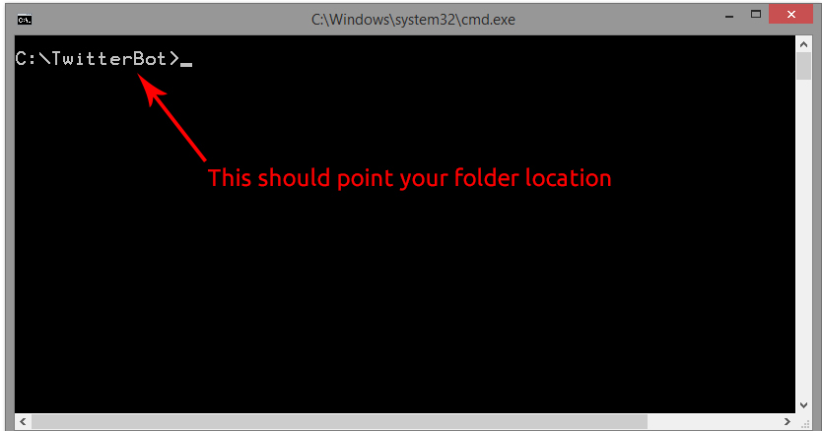

1. Install ‘Twit’ package using Node Package Manager.

Type in the command line:

C:\TwitterBot> npm install twit

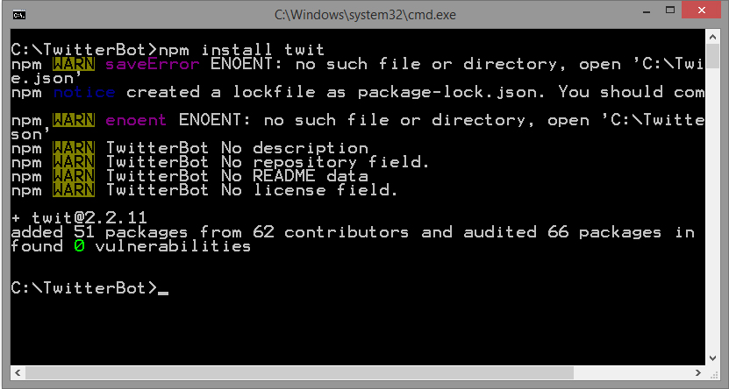

1. A new folder called ‘node_modules’ will be created in the TwitterBot folder with required packages.

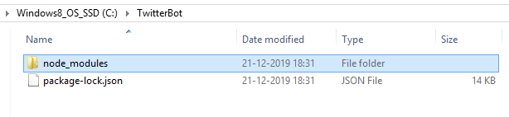

1. Download and place the ‘bot.js’ file inside this folder.

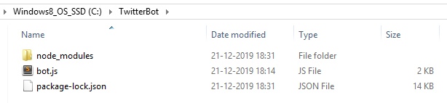

1. Go to <https://developer.twitter.com/>

Login with your twitter ID.

Create a new App (as hobbyist or student).

Fill the details.

1. Take the Key and Token values.

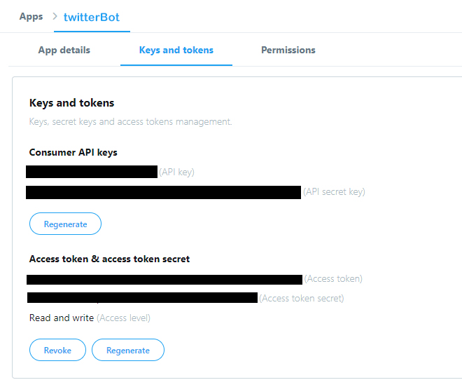

1. Open the ‘bot.js’ file using any text editor (notepad, sublime Text etc)
2. Replace the following four values in the code from your twitter account.

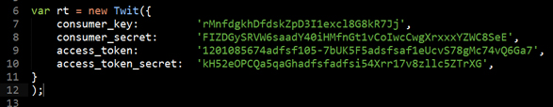

Note: the values mentioned here are junk

1. Edit the hash tags as required.



1. From the command terminal run the code

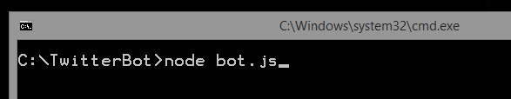

You should see your twitter account starts retweeting every two minutes from the search results of one of the hashtags

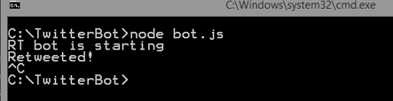

Enter Ctrl+C to stop the bot.

1. To keep running in the background install ‘Forever’ package

C:\TwitterBot> npm install forever

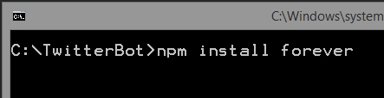

1. Run using the command

C:\TwitterBot> forever start bot.js

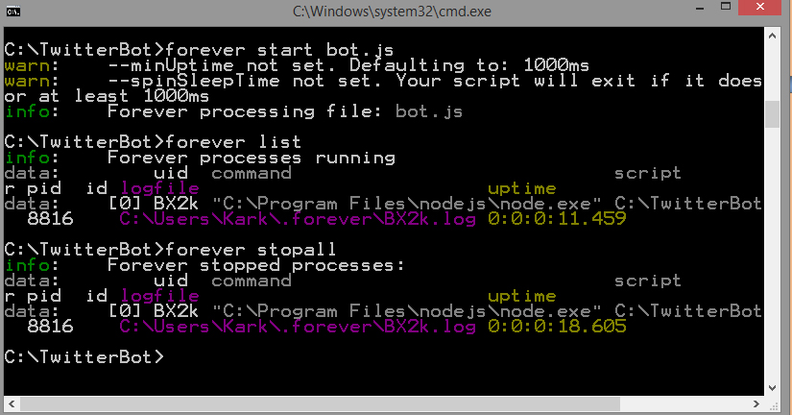

This will run the twitter bot in the background.

To see the list of running process type forever list

To stop the bot type forever stopall

You can keep running the twitter bot in the background when your PC is on

*** DONE ***

If you want to deploy the bot and run from Amazon EC2 server follow the procedure from the link below.

<https://shiffman.net/a2z/bot-ec2/>

For Detailed info check

<https://shiffman.net/a2z/twitter-bots/>